**Python Extension Pack**

**Python**

Description: A Visual Studio Code extension with rich support for the Python language (for all actively supported versions of the language: >=3.7), including features such as IntelliSense (Pylance), linting, debugging, code navigation, code formatting, refactoring, variable explorer, test explorer, and more!

**IntelliCode**

Description: The Visual Studio IntelliCode extension provides AI-assisted development features for Python, TypeScript/JavaScript and Java developers in Visual Studio Code, with insights based on understanding your code context combined with machine learning. This extension provides AI-assisted IntelliSense by showing recommended completion items for your code context at the top of the completions list.

**Django**

Description: Beautiful syntax and scoped snippets for perfectionists with deadlines

**Jinja**

Description: This extension adds language colorization support for the Jinja template language to VS Code.

Using: First, you will need to install Visual Studio Code 0.10. In the command palette (cmd-shift-p) select Install Extension and choose Jinja.

The downside of the Jinja language is that there is no defined file extension and as such, there is no way to detect it automatically in all cases. This extension will look for it in two file extensions - .html and .j2. The .j2 file extension is heavily used with Ansible which uses the Jinja2 engine underneath.

**autoDocstring - Python Docstring Generator**

Description: Visual Studio Code extension to quickly generate docstrings for python functions.

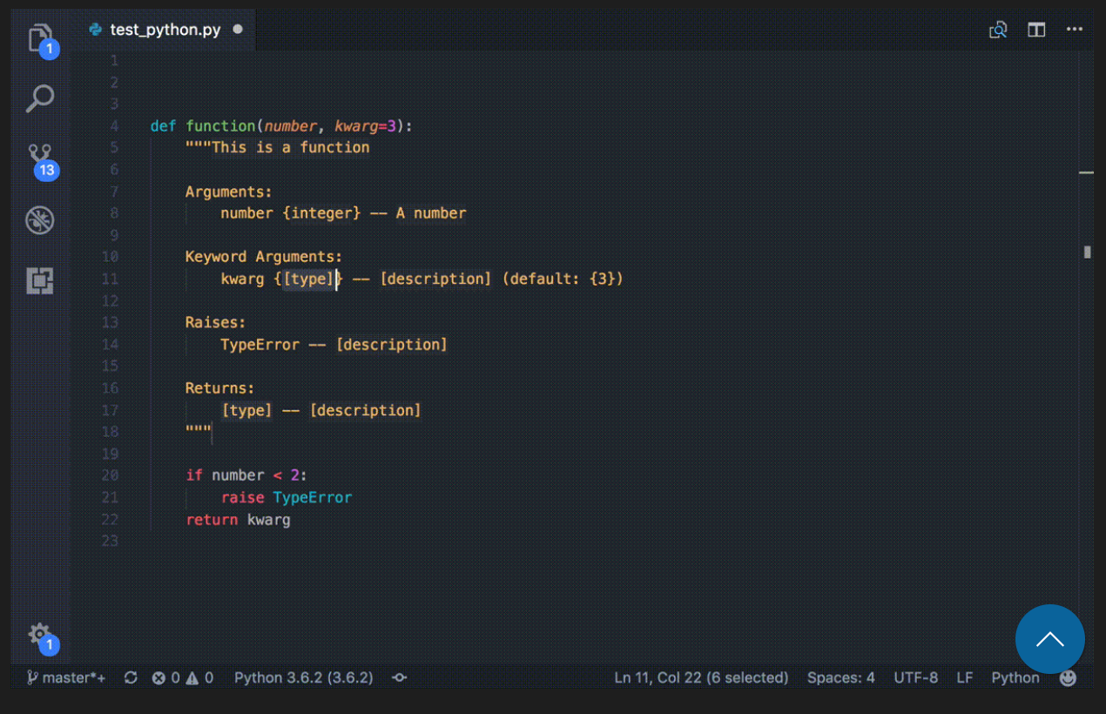

Features

* Quickly generate a docstring snippet that can be tabbed through.
* Choose between several different types of docstring formats.
* Infers parameter types through pep484 type hints, default values, and var names.
* Support for args, kwargs, decorators, errors, and parameter types

Usage

Cursor must be on the line directly below the definition to generate full auto-populated docstring

* Press enter after opening docstring with triple quotes (configurable """ or ''')
* Keyboard shortcut: ctrl+shift+2 or cmd+shift+2 for mac
  + Can be changed in Preferences -> Keyboard Shortcuts -> extension.generateDocstring
* Command: Generate Docstring
* Right click menu: Generate Docstring

**Python Indent**

Description: Visual Studio Code extension to quickly generate docstrings for python functions.

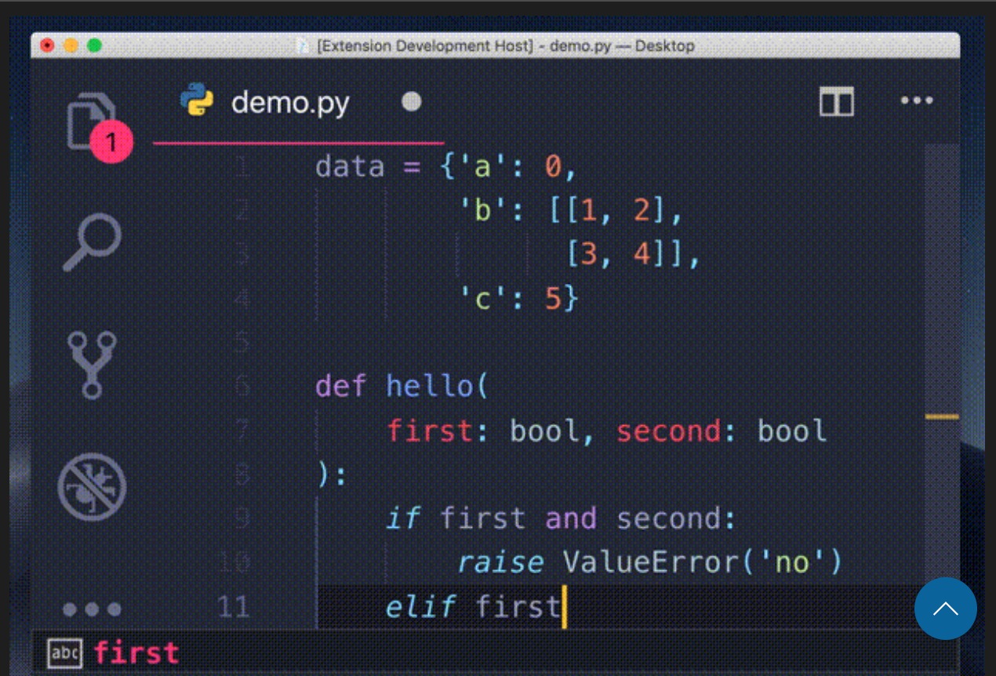

**Python Environment Manager**

Description: A Visual Studio Code extension that provides the ability to via and manage all of your Python environments & packages from a single place.

Features

* Viewing all of your Python environments grouped by their type (Conda, PyEnv, etc)
* Creating a terminal with the environment activated.
* Create/delete Conda and Virtual Environments.
* Install Python along with Conda using Micromamba
* Set a Python environment as the active workspace Python interpreter as used by the Python Extension
* View installed packages.